WIFI Chat Setup Information

User Access:

Password: 098765

Admin Tab Password: 123456

Setup Guide:

Step 1.

To begin the setup of this application download WAMP server from: <http://www.wampserver.com/en/#download-wrapper>

Step 2.

Install WAMP server. During the installation be sure to tick the box to install MySQL.

Step 3.

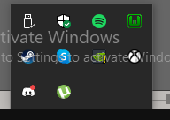Once the installation is launch WAMP and check your desktop tray to find the WAMP server logo. It should look like this:

Step 4.

Assure that all the services are working correctly. If they are the WAMP icon will be green as shown above. If not the WAMP logo will be either orange or red. If this is the case please consult the WAMP forum to troubleshoot any issues: <http://forum.wampserver.com/list.php?2>

Step 5.

Download the Zipped Code File that was submitted alongside the presentation named WIFICHAT.zip

Step 6.

Inside the zip will be a file named ‘Code’. Extract all the files inside this folder into the WAMP64 folder named www:

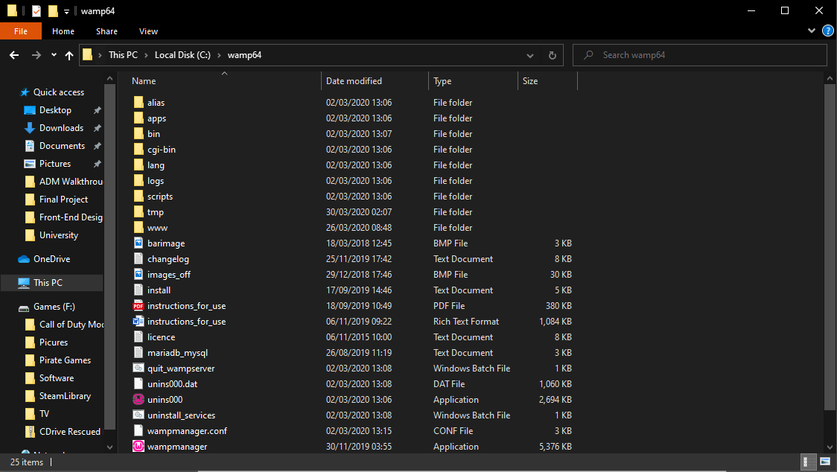

Step 7.

The inside of the www file should look something like this:

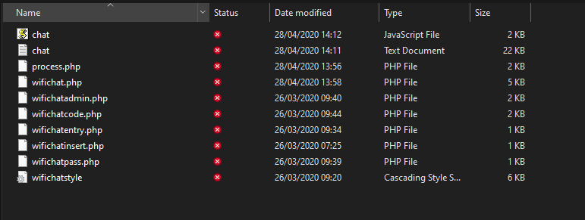

Step 8.

Check which port you have chosen to host on localhost. If it does not work on port 80 this could be due to an application such as Skype being open. If it continues to be troublesome change the port number by clicking the WAMP icon and following the menu below.

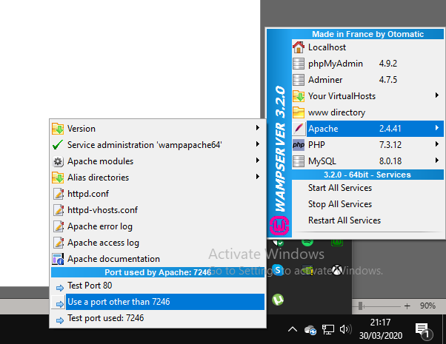

Step 9.

If it is necessary for you to change the port number, you may need to also change the httpd.conf too. Follow what has been typed below replacing “7246” with whichever port number you have chosen.

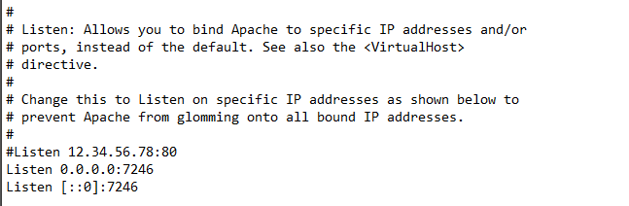

Step 10.

Return to the WIFICHAT.zip file you originally downloaded. Inside here will be another folder named database. Inside here is a .sql file which will be used to import the database structure to your WAMP server. To do this go phpMyAdmin on the WAMP menu bar:

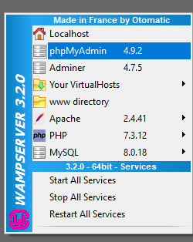

Step 11.

Login to the database. The username should be root and the password should be blank.

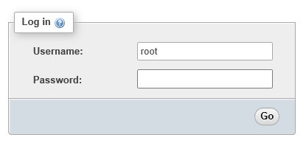

Step 12.

Try importing the database file “pass.sql” from WIFICHAT.zip into the database.

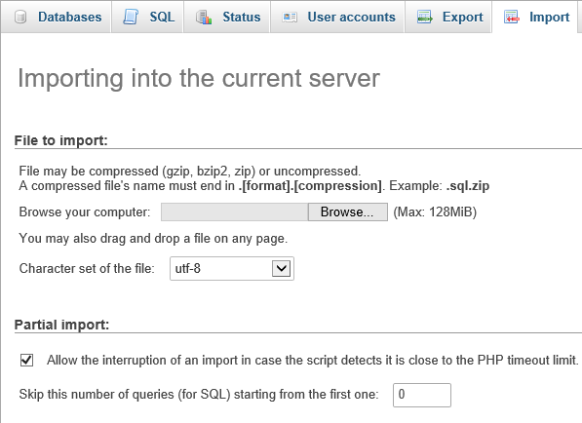

If this is unsuccessful, try creating a new database named “wifichat” and importing again.



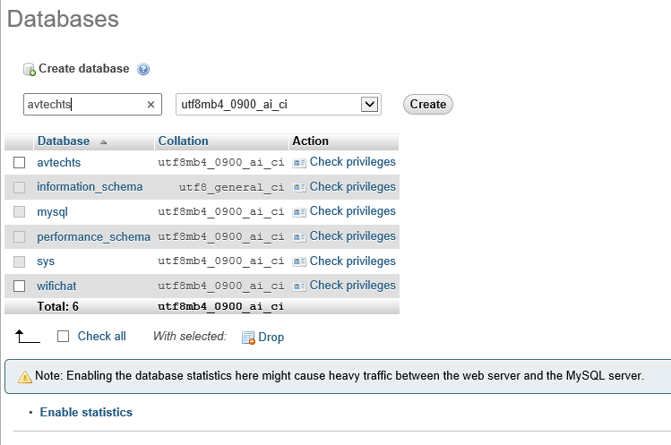

Step 12.

Now you can restart the services by clicking the WAMP icon and clicking ‘Restart Services’.

Go to a web browser and type: localhost:[YOUR PORT NUMBER]/wifichat.php

If everything has worked successfully you should be presented with the login page where the logins can be entered:

